Call for Nominations
2024 Health Professions Educator Award

The Health Professions Educator Award acknowledges the longitudinal contributions and sustained excellence to health professions education within the Faculty of Health Sciences, McMaster University.

Nominations are welcome from across the Faculty of Health Sciences. It is expected that nominees will be senior faculty and leaders in their respective programs or departments that have made substantial, sustained contributions to education. This may include contributions to some and not necessarily all the following domains:
- innovation in clinical / classroom teaching,
- graduate supervision in health professions education,
- mentorship of health professional learners and faculty,
- education program design / innovation, or
- education scholarship.

Nominations should describe the contribution to the Faculty of Health Sciences, contributions at a regional and national level are also considered.

Application
- Cover page (see page 2)
- Letters from two nominators that articulate with examples the substantial, sustained contribution of the nominee to health professions education at McMaster.
- Nominee’s abbreviated curriculum vitae (no more than 5 pages)

Previous nominees are eligible for re-submission.

The application should be submitted to: merit@mcmaster.ca as a single .pdf file labelled <nominee’s last name>.2024HPEA

Deadline for applications is April 22, 2024 @ 11:59pm

Past Winners
- 2023 – Kristen Burrows, PhD – Physician Assistant Education Program
- 2022 – Elizabeth Shaw, MD – Department of Family Medicine
- 2021 – Azim Gangji, MSc – Department of Medicine
- 2020 – Sarah Wojkowski, PT, PhD – School of Rehabilitation Science
- 2019 – Janet Landeen, PhD – School of Nursing
- 2018 – Robert Whyte, MD – Undergraduate Medical Education Program
- 2017 – Sue Baptiste, MHSc – School of Rehabilitation Science
- 2016 – Debra Stewart, MSc – School of Rehabilitation Science
- 2015 – Allyn Walsh, MD – Department of Family Medicine

** The Health Professions Educator Award will be presented at the Norman Education Research Day (June 5, 2024).
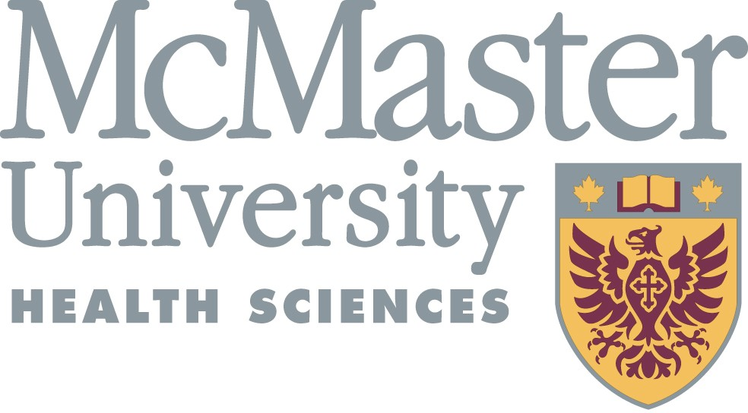

Name of Nominee: ______________________________________________________

Nominee E-mail: _________________________________________________________

Nominee Department: ___________________________________________________

Nominee Current and Relevant Past Academic Positions:
•
•
•

Nominator 1:
Name

Academic Position:

Relationship to nominee (e.g. peer, administrative or leadership role)

Nominator 2:
Name:

Academic Position:

Relationship to nominee:

